multi-Year Requirements – Admin Module

Table of Contents

Problem Statement: 3

Enrollment Setup: 3

Group Navigation- add Enrollment Setup link 3

User Story: 3

Proposed Solution: 3

Enrollment Setup Page 4

User Story: 4

Proposed Solution: 4

Add/Edit Enrollment Year 5

User Story: 5

Proposed Solution: 5

Data Needs: 5

Add/Manage Plans 7

Manage plan grid view 7

User Story: 7

Proposed Solution: 7

Open question: 7

Add plan Modal 8

User Story: 8

Solution: 8

Filter Criteria: 8

Plan selection section 8

All Plans Tab 8

Favorites tab: 8

Open Question: 9

Plan setup page 10

User Story: 10

Proposed Solution: 10

Details 10

Costs Tab 11

Maintenance Screens: 13

Generate Census 13

Employee list 13

Employee Summary 13

Individual Send Forms 13

Group Enroll 14

Preview Forms 14

Send Forms 14

Send EDI 14

Plan Selection Report 14

Manage Documents 14

Manage Forms 15

Send welcome letters and send reminder emails 15

# Problem Statement:

To ensure employees benefits are current throughout multiple enrollment years. Employees need to be able to make life event changes and/or enroll for the next benefit year.

This project aims to provide the functionality that allows for current year changes as well as subsequent year changes concurrently, while maintaining the existing functionality around the management of these actions, including assigning plans, sending apps/forms and communicating changes as needed.

# Enrollment Setup:

## Group Navigation- add Enrollment Setup link

### User Story:

As a broker I would like the option to update my enrollment year information from the context menu.

### Proposed Solution:

In the Group's Navigation list, a link should be added to bring the users to the enrollment year setup page

1. Add a link to navigation menu: "Enrollment Setup"
   1. Link will bring user to new page (additional story)
2. Icon needed: ben provided

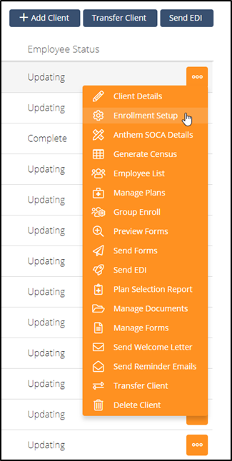

## Enrollment Setup Page

### User Story:

As a broker I would like the ability to add, edit, view, and delete enrollment years.

### Proposed Solution:

Create a new enrollment year setup page to display all the past, present, and future enrollment years.

1. Grid view of all benefits year’s setup
   1. Columns of grid:
      1. Name
      2. Open Date - Closed Date
      3. Effective Date - End Date
      4. Renewal Date
      5. Default-
         1. Default will be used as the display option for enrollment year dropdown throughout admin site
   2. Context Menu
      1. Edit
         1. Once the enrollment year has ended it will be a view only page.
      2. Copy
         1. Option will copy all information from this selected enrollment year to a new one.
         2. Exceptions: enrollment name, open date, closed date, effective date, end date.
      3. Delete
         1. Only for enrollment years that have not started yet.
         2. Sys admins should have access to delete enrollment years at any time
2. Once a year ends or a new enrollment year begins, all previous year setup pages will be view only. the user will not be allowed to delete them as well.

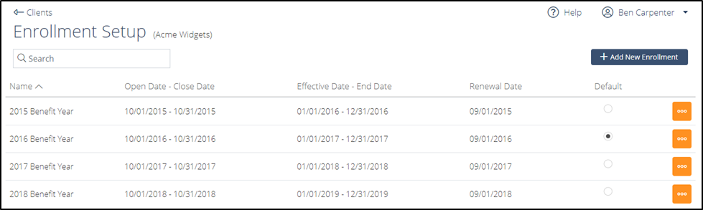

## Add/Edit Enrollment Year

### User Story:

As a broker I would like the ability to edit and add enrollment date information.

### Proposed Solution:

Create new page to allow a broker to setup or edit an existing or future enrollment year.

**Note: All fields on this page is a per year setup. Any features enabled or disabled should only affect the enrollment year that is being edited not any other enrollment year.**

### Data Needs:

Move fields from current Client details page to enrollment page. with addition to new fields.

1. Enrollment Name
   1. Open text field
   2. Will be used in drop down location throughout admin site
2. Open date (no change)
3. Close date (no change)
4. Effective Date
   1. Lock down field once effective date is reached
   2. Sys admins should have access to edit field
5. End Date
   1. Field is to determine the end of a benefit period.
   2. New enrollments cannot have an effective date before the previous years end date.
   3. End date must be greater than same years effective date and less than next year’s effective date
6. Renewal Date (no change)
7. Choose Coverage Line
   1. Accordion style selection.
      1. Coverage line selection will be per enrollment year
8. Prescreen/Plan Selection section toggle (No change)
   1. Add tool tip next to choose workflow
9. Prescreen check box options (no change)
10. Plan selection check box options (no change)

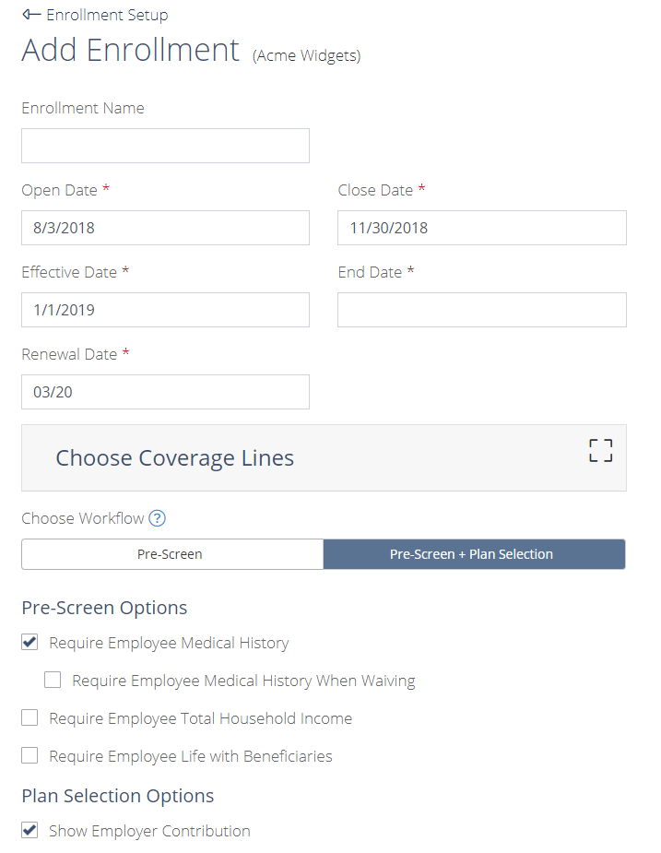

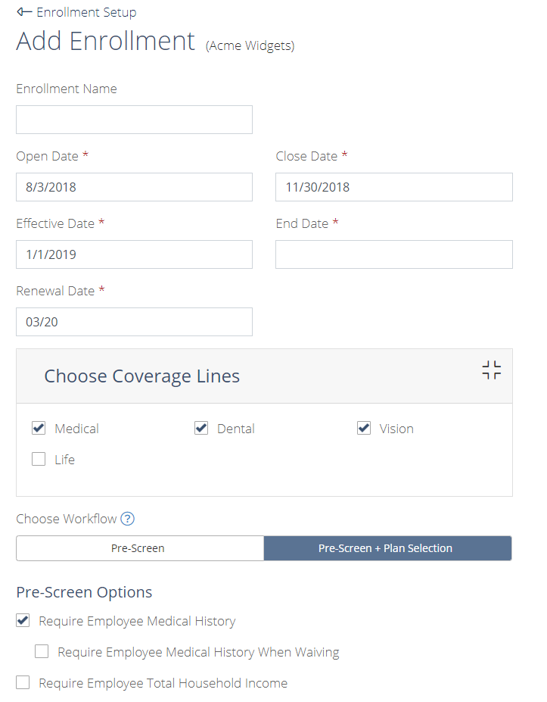

# Add/Manage Plans

## Manage plan grid view

### User Story:

As a broker, I need to be able to add/edit/delete plans for multiple years so that employees can view / act on them.

### Proposed Solution:

Update to manage plans page to the new look and feel

1. User should be able to setup unique contribution and pricing for each individual enrollment year
2. Enrollment Year drop down
   1. Any enrollment year in the past should be a view only, user should not be able to delete or edit.
3. Add plan button (story for how it works)
4. Grid view
   1. Plan Name
      1. selecting plan name will allow editing
   2. Carrier
   3. Coverage line
   4. State
   5. SBC
   6. SOB
   7. Contribution
      1. green or yellow icon depending on completion or not
   8. Costs
      1. green or yellow icon depending on completion or not
   9. Delete
      1. should have are you sure modal when deleting

### Open question:

should we provide a copy plan feature? If so, do we just copy the plan and not the contribution and/or pricing or copy all or a variation?

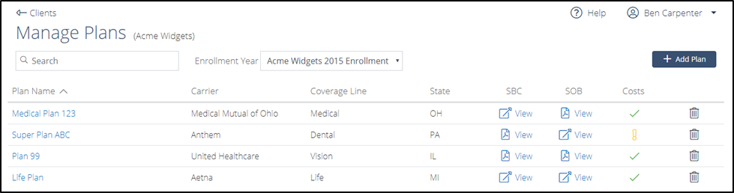

## Add plan Modal

### User Story:

As a broker I would like the ability to pick a new plan or choose a plan from favorites list.

### Solution:

When user selects add plan button from the plan list page, a modal window should display

### Filter Criteria:

1. Tabs: All plan, Favorite Plan
   1. Default is All Plans
2. Select different state link
   1. Text: Showing ALL plan available for (Client Name) in (Client State).
   2. Default state is the groups state
   3. Select different state link: If selected, a state drop down option will appear next to ‘Coverage Line’ option
3. Coverage line (no change)
4. Carrier (no change)

### Plan selection section

### All Plans Tab

Once state, coverage line, and carrier are selected, plans list will appear.

1. Plans list
   1. Favorite option
      1. Once selected this will auto put the plan within the favorites list.
      2. User can select or deselect favorites
   2. Plan name
   3. State
   4. Coverage line
   5. Carrier
   6. SBC link
   7. Benefit summary link
2. To pick a plan user will select a plan name row and choose the add button at the bottom. User can deselect plan by just re-selecting highlighted plan.
3. Should maintain criteria and plan as if user switches back and forth between all plans tab and favorites plans tab.
4. If both tabs have a selection of a plan the tab that is being viewed should be the plan that is added.

### Favorites tab:

1. Favorites tab should also have same search criteria as ‘All Plans’
2. When user deselects the star, the plan will be removed from the favorites list.
3. Favorites list should be kept on a Per User level.

### Open Question:

Should we keep the unchecked star on the page until either they go back to all plans tab or hits add or cancel?

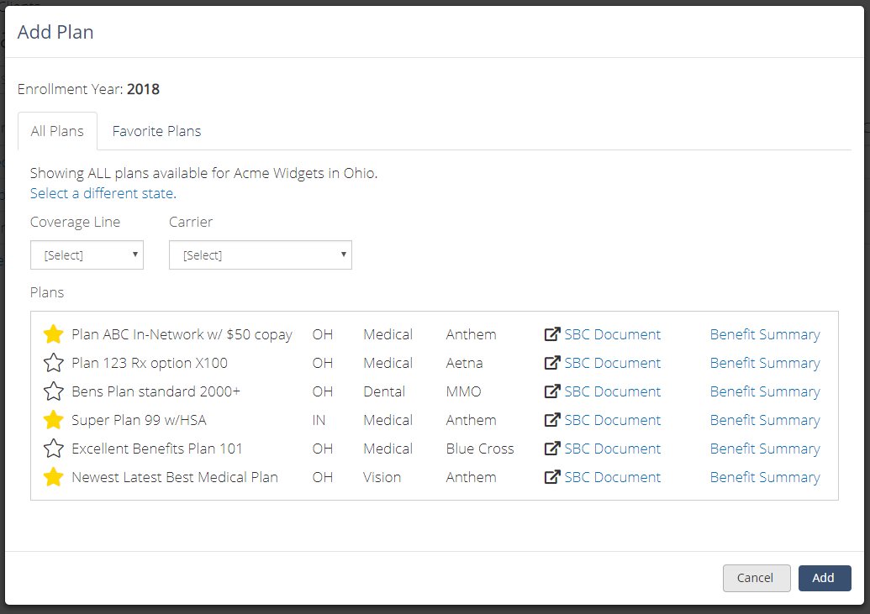

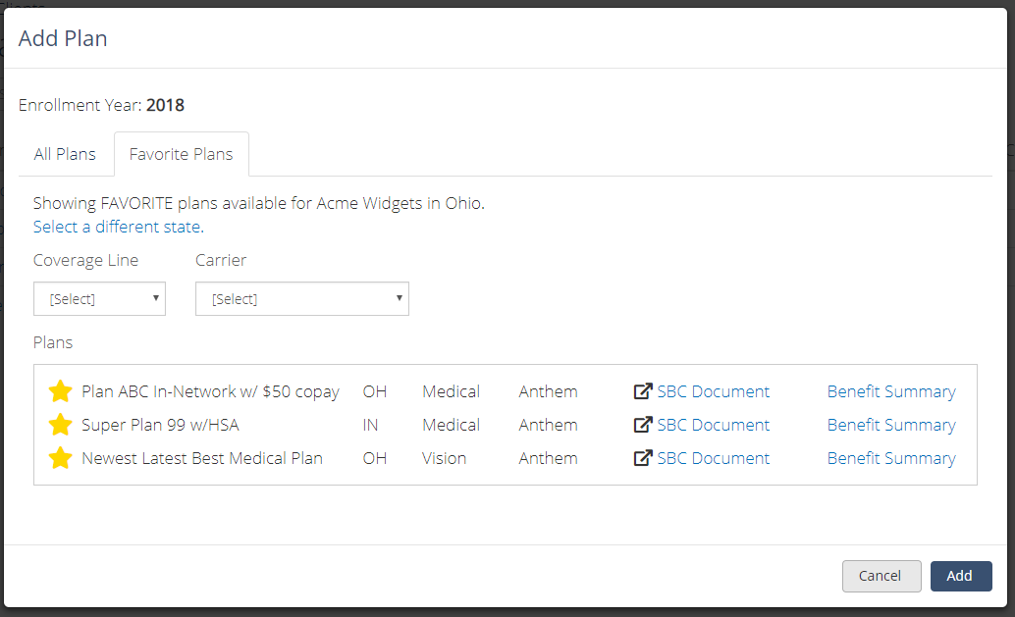

## Plan setup page

### User Story:

As a broker I would like simple easy way to add plan descriptions and costs for plan setup.

### Proposed Solution:

Move Details and Costs to one page under 2 tabs

### Details

1. Original Name
2. Original Description
3. Custom Name
4. Custom Description

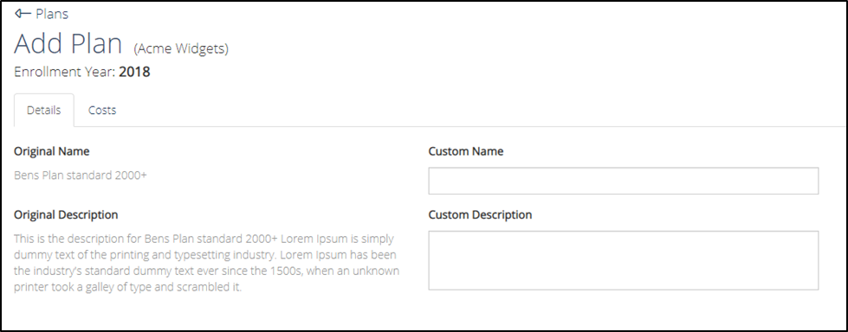

## Costs Tab

1. Composite rate setup
   1. Rate Structure: toggle choice of Composite or Age-Band
   2. Coverage Tiers: drop down of current coverage tier options
      1. Once a coverage tier is selected the pricing and contribution options will display
   3. Defined contribution check option
   4. ER Contribution
      1. Toggle between $ or %
      2. Coverage Tier entry options
   5. HSA Contribution
   6. Enter total MONTHLY costs for each tier

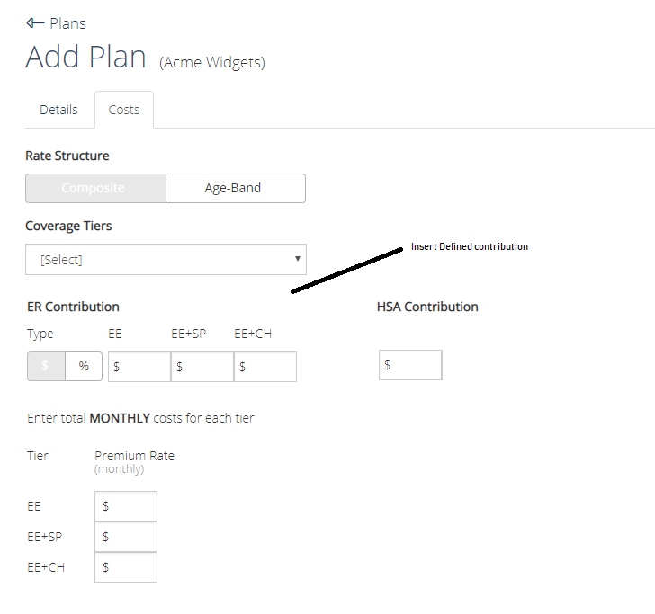

1. Age band setup
   1. Rate Structure: toggle choice of Composite or Age-Band
   2. Start age; increment; end age
   3. Use ACA rate table
   4. Include tobacco rates
   5. Include gender rates
   6. Only use employees age for rates
   7. Defined contribution check option
      1. When selected replace ER contribution section
   8. ER Contribution
      1. toggle between $ or %
      2. Employee or Dep option
   9. HSA Contribution
   10. Enter total MONTHLY costs for each age banded tier

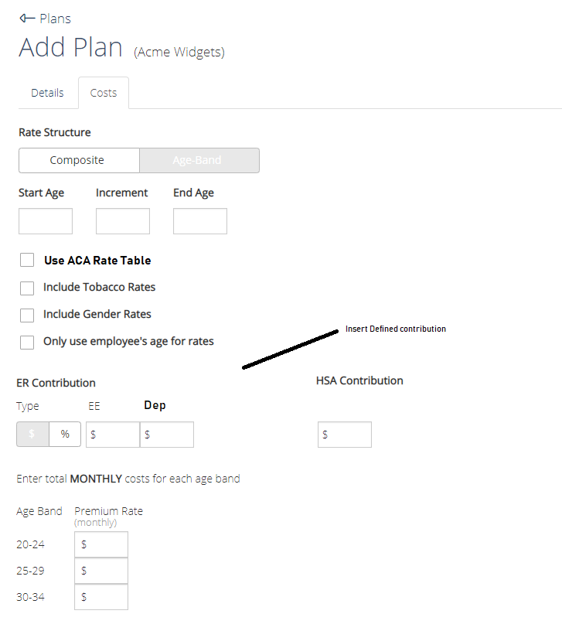

Employee Record:

### User Story:

As a user I would like the ability to choose my enrollment data for each benefit year as well as add dependents or remove dependents from each enrollment year.

### Proposed Solution:

Need to provide the ability to save multiple years of enrollment data for employees and dependents

### Data Needs

1. Data that should be saved per enrollment year is:
   1. Coverage selection
   2. Plan selection
   3. Beneficiaries
   4. Dependents
2. The employee’s personal info, employer info, and MHQ Data can be maintained as one record.

### Open question:

1. When should we copy dependents over from year to year.
2. When employee starts enrollment?
   1. Pros- most accurate date
   2. Cons- can’t print any census’
3. Or when new enrollment year is created.
   1. Pros-can download census or anywhere else deps info is needed for that enrollment year.
   2. Cons- data can be different from the employee’s previous year which causes confusion and complaints.

# Maintenance Screens:

## Generate Census

As a broker I would like to pick which enrollment year I would like to generate a census a for.

Solution:

Add Drop down of enrollment year selection for generate census page.

Enrollment year selected should reflect that enrollment years setup.

## Employee list

"As a broker, I would like to know the enrollment status of employees for each enrollment year from the employee list page.

Solution:

On the employee list page, the enrollment year drop down. All employee will stay the same based on the enrollment year selected only their status should update to reflect the enrollment year being viewed.

Open question do we need a way to upload the census for a specific year? Employees will be used crossed years, but dependents will be limited per year.

## Employee Summary

As a broker I would like the ability to view an employee summary for a specific enrollment year

Solution:

From the employee summary page there should be a drop down that allows the broker to pick which enrollment year they want to view.

## Individual Send Forms

As a broker I would like the ability to select which enrollment year I would like to send forms for an individual

Solution:

On the individual send forms page add an enrollment year drop down. This is same logic as send forms page.

## Group Enroll

As a broker I would like the ability to select which enrollment year I would like apply plans for on the group enroll page

Solution:

On the Group enroll page add an enrollment year drop down. When selected the plan and employees listed should be reflected on the page.

## Preview Forms

Do we want to add column of enrollment year?

## Send Forms

As a broker I would like the ability to select which enrollment year I would like to send forms for an individual

Solution:

On the individual send forms page add an enrollment year drop down.

Based on enrollment year selected the corresponding forms and employee applications for be attached.

EDI & MyCobra need to make sure we send the correct forms for

## Send EDI

As a broker I would like the ability to select which enrollment year I would like to send EDI files

Solution:

Add the enrollment year drop down to the EDI file modal window.

Based on enrollment year selected the corresponding forms and employee applications for be attached.

## Plan Selection Report

As a broker I would like the ability to select which enrollment year I would like to download a plan selection report for

Solution:

Add a modal window with the enrollment year dropdown

Based on the enrollment year selected the corresponding employee information should be loaded.

## Manage Documents

As a broker I would like the ability to select which enrollment year I would like to upload documents for.

Solution

Add an enrollment year dropdown to allow the broker to upload documents to that year.

When changing enrollment year, the document list should update accordingly.

## Manage Forms

**User Story:**

As a broker, I need to be able to select which enrollment year I would like to manage forms for.

**Solution:**

MANAGE FORMS PAGE:

Add Enrollment year drop down to allow a broker to select which year they want to edit.

Based on the enrollment year selected the corresponding forms should display (if any).

## Send welcome letters and send reminder emails

As a broker I would like to choose which enrollment year I would like to send welcome and reminders emails for.

Solution:

Within the modal add enrollment year to allow the broker to choose which enrollment year data to send for.